Using the LCD RGB Backlit Display

Scratch Version

February 25, 2017

# Screen Clipping

# Overview

The LCD RGB Backlit Display is a little screen that you can write words on and change colors. It’s useful for projects where you need to tell the user something, but you don’t have a computer screen.

# Setting up

Power up your Raspberry Pi/GrovePi and start up Scratch. If you haven’t done this before, work through the “Getting started with Grove Sensors” document. Your screen should look like this:

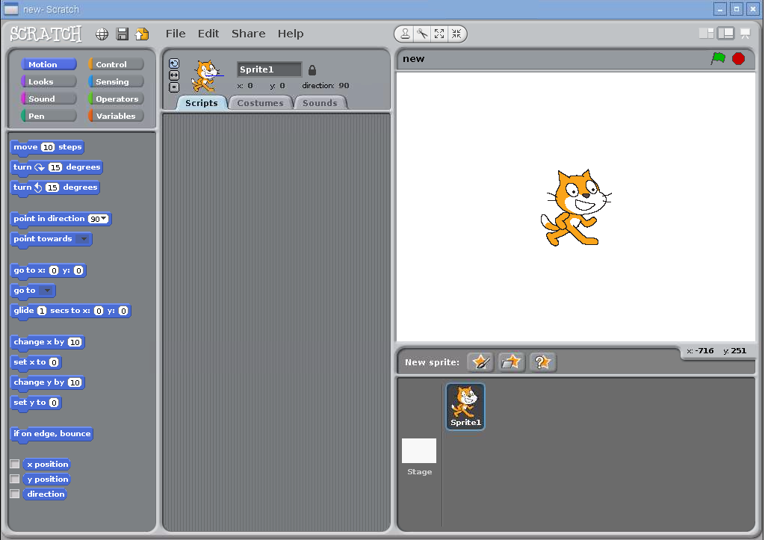

Now, find the Grove-LCD RGB Backlight Display in the kit. It should be in a protective pink bubble wrap pouch. At the end when you’re done with the display, be sure to put it back in the protective pouch for the next person. Also, find a Grove sensor cable and connect the RGB Backlit Display to one of the Grove Pi’s I2C ports. Any I2C port is fine. For this example, we used I2C-1, but the code stays the same if you use one of the other ports. Here’s what the connections should look like:

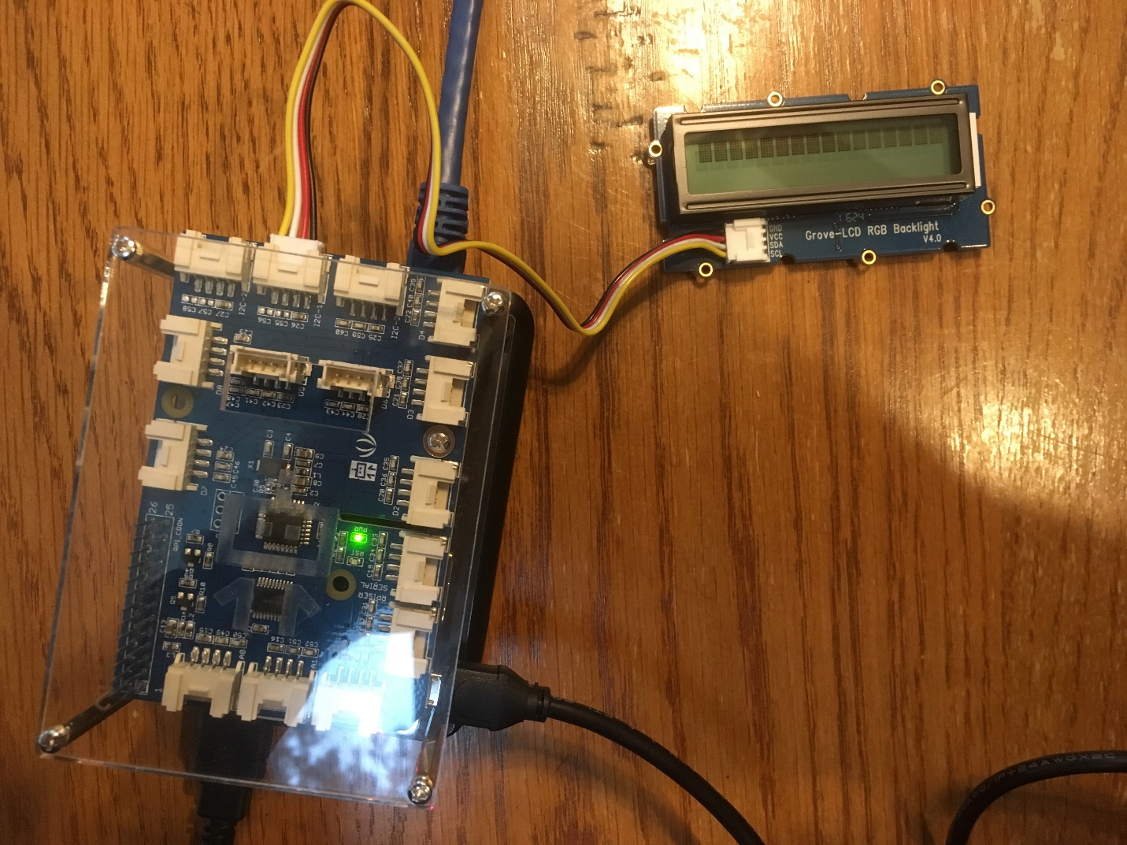

# Programming the display

The RGB Backlit Display has two commands: one sets the background color and the other sets the text. Both commands use the *broadcast* block. To set the text, broadcast a message that starts with the letters “LCDtxt”. Try it out by placing a “broadcast” block:

Screen Clipping

Click on the black triangle to change the message and type in “LCDtxtHello”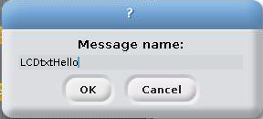:

Click OK. To test it out, double click on the *broadcast* block that you just made (capital letters do not work in this version):

Smashing “LCDtxt” together with the words that you want displayed is not only hard to read, but you can’t show text from a variable. The *join* block is useful for fixing this. Here’s an example piece of code:

Screen Clipping

Changing the color is similar. The magic letters to broadcast are “LCDcol” followed by the hex value for the color. Hex colors are a common way for programmers to specify colors. You can find more information by reading the Wikipedia article <https://en.wikipedia.org/wiki/Web_colors> or by searching the Internet for “hex colors”. Here are some example hex colors:

|  |  |
| --- | --- |
| Color | Hex value |
| Black | 000000 |
| White | ffffff |
| Bright red | ff0000 |
| Bright green | 00ff00 |
| Bright blue | 0000ff |
| Yellow | ffff00 |
| Cyan | 00ffff |

For example, the following code sets the display’s background to yellow:

Screen Clipping

If this doesn’t work for you, check that there isn’t an extra space after “LCDcol” and that the hex color is exactly 6 characters long.

To turn the background of the display off, set it to black:

Screen Clipping

# Common problems

## Text disappears when updating the LCD in a loop

If you update the text on the display too quickly, the text will disappear. Here’s a script that has this problem:

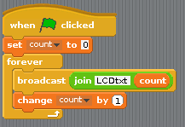

When you click the green flag, the script is supposed to count from 0. In reality, the display goes blank and when you click the red stop button, it takes a minute before a number appears. One fix is to add a *wait* block to slow the loop down. Another option is to not update the display every time through the loop. Here’s an example:

